Instruction for writing project Report:

- Font type (Times New Roman) must be same as in this report.
- Index for figures and tables must be separate as given in project.
- If figure or table comes in chapter one then title will be Figure 1.1, Figure1.2, ... so on and Table 1.1, Table 2.1,..so on. For chapter two Figure 2.1, Figure 2.2,…and Table 2.1, Table 2.2,…. and so on.
- Normal Text of font Size 12 in Times New Roman font style, not bold and justify format(Ctrl z).
- Chapter number and name with font size 16 in Times New Roman font style (Bold letters, each letter is in Uppercase, aligned to centre).
- Main Heading of chapters are with font size 14 in Times New Roman font style (Bold letters, each letter is in Uppercase and justify format (Ctrl z)).
- Sub heading of chapters are with font size 12 in Times New Roman font style (without Bold, each word is in sentence case and justify format (Ctrl z)).
- Code of project must be added as part of appendix.
- Snapshot must be taken from running project.

PROJECT REPORT
TITLE
Submitted in partial fulfilment of the requirement for the award of the degree of

BACHELOR OF TECHNOLOGY
IN
COMPUTER SCIENCE & ENGINEERING - Specialization
Submitted by
NAME1 University Roll No-
NAME2
Under the guidance of
Mr. XYZ
DESIGNATION
Project Group No:

Department of Computer Science and Engineering
Graphic Era Hill University
May, 2026



CANDIDATE’S DECLARATION
I/We hereby certify that the work which is being presented in the project progress report entitled “Title of the project” in partial fulfillment of the requirements for the award of the Degree of Bachelor of Technology in Computer Science and Engineering - Specialization in the Department of Computer Science and Engineering of the Graphic Era Hill University, Dehradun shall be carried out by the undersigned under the supervision of Guide Name, Designation, Department of Computer Science and Engineering, Graphic Era Hill University, Dehradun.

Name1 University Roll no1 signature
Name2 University Roll no2 signature

ACKNOWLEDGEMENT

Thanks to Mr. Bill Gates for creating Microsoft Word and with it an easy-to-use word processor. Use your own language.

Name of student 1 Name of student 2
Roll no. Roll no.

ABSTRACT

A simple template is provided here in MS Word class. This can be used to easily write a thesis suitable for submission at GEHU. The class provides options for B.Tech.

The formatting is (to the best of knowledge of the authors) as per the guidelines of the institute.
TABLE OF CONTENTS

ACKNOWLEDGEMENT i
ABSTRACT ii
LIST OF TABLES iv
LIST OF FIGURES v
ABBREVIATIONS vi
NOTATIONS vii

INTRODUCTION 1

MS Word features………………………………….……………….................... 2

MS Word figures……………………………………………………………….. 2

MS Word options………………………………………………………………. . 2

REQUIREMENT ANALYSIS
2.1----

A SAMPLE APPENDIX 3
LIST OF TABLES
Sno. | Table Description / Caption | Page No

LIST OF FIGURES

Sno. | Figure Description / Caption | Page No

ABBREVIATIONS

GEHU Graphic Era Hill University
HTML Hyper Text Markup Language
NOTATIONS

α Scale parameter
β Depth angle in degrees

CHAPTER 1
(SAME FORMAT FOR OTHER CHAPTER)

INTRODUCTION AND MOTIVATION – 3 to 4 pages

(OR ANY OTHER HEADING)

This is the first chapter of the thesis/dissertation template. This is to indicate the formatting style of the report. The line spacing is 1.5, with the indent at the new paragraph.
The new paragraph can start in the next line, with no gap. There is an indentation of 0.2” at the beginning of the paragraph. Paragraph in the thesis will always be justified, not left-centered.

MS Word features
A new section paragraph starts with no indentation. However, there will be a regular indentation of 0.2” at the start of next paragraph.
If we want to insert a figure in the text, it has to be centered and suitable title be added for the same. For example,
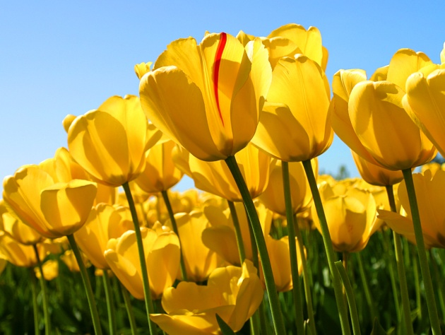

Figure no and caption

CHAPTER 2

OBJECTIVES OR PROBLEM STATEMENT
Point wise explanation of each objective

CHAPTER 3

SOFTWARE AND HARDWARE REQUIREMENTS

( Proper system requirements and SRS should be included in this chapter with proper diagram)
This section may include complete SRS of the project.

CHAPTER 4

project methodology / design

( Algo and blue print should be included in this chapter with proper diagram)
This section may include architectural design of the project, implementation of any objectives, pseudo code/ algorithms, discussion of the results, etc.

CHAPTER 5

IMPLEMENTATION and results

The new paragraph can start in the next line, with no gap. There is an indentation of 0.2” at the beginning of the paragraph. Paragraph in the thesis will always be justified, not left-centered.

CHAPTER 6

Conclusion AND fUTURE SCOpe

The new paragraph can start in the next line, with no gap. There is an indentation of 0.2” at the beginning of the paragraph. Paragraph in the thesis will always be justified, not left-centered.

References
[1] Ji, XunSheng, et al. "Application of the digital signal procession in the MEMS gyroscope de-drift." Nano/Micro Engineered and Molecular Systems, 2006. NEMS'06. 1st IEEE International Conference on. IEEE, 2006.
[2] Nussbaumer, Henri J., and Martin Vetterli. "Computationally efficient QMF filter banks." Acoustics, Speech, and Signal Processing, IEEE International Conference on ICASSP'84.. Vol. 9. IEEE, 1984.
Sites those you used

Any other reference

List of Publications
(if any)
- Ji, XunSheng, et al. "Application of the digital signal procession in the MEMS gyroscope de-drift." Nano/Micro Engineered and Molecular Systems, 2006. NEMS'06. 1st IEEE International Conference on. IEEE, 2006.

APPENDIX A
(Code)

It will contain code of project/software.

